ENGL 3110 - Exam One - Spring 2026
Total Points: 100 • Time: 70 Minutes
Resources: Anything except help from other people or AI/LLM (ChatGPT, etc.)
Sections:
- Section A: Multiple Choice — 50 points (25 questions, 2 points each) — Suggested Time: 30 minutes
- Section B: Sentence Labeling and Diagramming — 50 points (5 sentences, 10 points each) — Suggested Time: 30 minutes
- Bonus — 10 points (5 questions, 2 points each)
STUDENT NAME: ____________________________________________________________

Section A: Multiple Choice (50 points)
Instructions: For each question, select the best answer and write the letter in the blank provided.

Section A1: Morphology and Word Structure (Questions 1–6, 12 points)
Question 1: How many morphemes does the word "disagreements" contain? (2 pts)
Answer: _____
a. 1
b. 2
c. 3
d. 4
Question 2: Which of the following words contains exactly one morpheme? (2 pts)
Answer: _____
a. unfriendly
b. describe
c. replayable
d. misplace
Question 3: The suffix -tion typically creates which word class? (2 pts)
Answer: _____
a. Verb
b. Adjective
c. Noun
d. Adverb
Question 4: Which word is an example of a compound (formed from two free morphemes)? (2 pts)
Answer: _____
a. understand
b. carpet
c. bookcase
d. receive
Question 5: The word "unhelpful" contains how many morphemes? (2 pts)
Answer: _____
a. 1
b. 2
c. 3
d. 4
Question 6: Which of the following correctly identifies the morphemes in "rebuilding"? (2 pts)
Answer: _____
a. re- (bound) + build (free) + -ing (bound)
b. re- (free) + build (free) + -ing (bound)
c. rebuild (free) + -ing (bound)
d. re- (bound) + building (free)

Section A2: Open and Closed Classes (Questions 7–16, 20 points)
Question 7: Which test reliably distinguishes adjectives from determiners? (2 pts)
Answer: _____
a. Adjectives can be pluralized
b. Adjectives can be “gradeable” — they have comparative and superlative forms (e.g., taller/tallest or more challenging/most challenging)
c. Adjectives always appear after the noun
d. Adjectives cannot appear before nouns
Question 8: According to the basic structure of English sentences, every sentence (S) divides into which two parts? (2 pts)
Answer: _____
a. Determiner + Sentence
b. Noun + Verb
c. Subject NP + Predicate VP
d. Adjective Phrase + Verb Phrase
Question 9: Which of the following word classes is an open class? (2 pts)
Answer: _____
a. Determiners
b. Pronouns
c. Adjectives
d. Prepositions
Question 10: Which feature best distinguishes determiners from adjectives? (2 pts)
Answer: _____
a. Determiners appear after the noun
b. Determiners can be modified by "very"
c. Determiners must appear before any adjectives in a noun phrase
d. Determiners describe qualities of the noun
Question 11: In the phrase "the tall student from Ohio," which word is the head of the noun phrase? (2 pts)
Answer: _____
a. the
b. tall
c. student
d. Ohio
Question 12: Which of the following words is a determiner? (2 pts)
Answer: _____
a. beautiful
b. quickly
c. every
d. student
Question 13: "The professor entered the room and placed her notes on the desk." What is the antecedent of "her"? (2 pts)
Answer: _____
a. The room
b. The professor
c. The desk
d. her notes
Question 14: Pronouns replace which of the following elements? (2 pts)
Answer: _____
a. Only the head noun
b. The entire noun phrase
c. Only the determiner and noun
d. The verb phrase
Question 15: Which of the following words is a preposition? (2 pts)
Answer: _____
a. quickly
b. beautiful
c. through
d. they
Question 16: Which of the following is NOT a determiner? (2 pts)
Answer: _____
a. the
b. every
c. very
d. some

Section A3: Parts of Speech in Context (Questions 17–25, 18 points)
Sentence for Questions 17–18: "Several enthusiastic students quietly studied the challenging material."
Question 17: Which word in the sentence above is a determiner? (2 pts)
Answer: _____
a. enthusiastic
b. Several
c. quietly
d. challenging
Question 18: In the sentence “Several enthusiastic students quietly studied the challenging material,” which word is an adverb? (2 pts)
Answer: _____
a. Several
b. enthusiastic
c. quietly
d. material
Question 19: "The professor with the briefcase lectured brilliantly." What part of speech is "with"? (2 pts)
Answer: _____
a. Conjunction
b. Determiner
c. Preposition
d. Adverb
Question 20: "My sister carefully examined their proposal." Which word is functioning as a verb? (2 pts)
Answer: _____
a. My
b. sister
c. carefully
d. examined
Question 21: "Three playful kittens explored the mysterious basement." Which word is an adjective? (2 pts)
Answer: _____
a. Three
b. playful
c. explored
d. basement
Question 22: "She quickly ran to the store." What type of phrase is "to the store"? (2 pts)
Answer: _____
a. Noun phrase
b. Verb phrase
c. Adjective phrase
d. Prepositional phrase
Question 23: In the phrase "the extremely tall building," what word class does "extremely" belong to? (2 pts)
Answer: _____
a. Adjective
b. Adverb
c. Determiner
d. Noun
Question 24: In the sentence “The professor from the university in Boston retired last spring,” what word does the prepositional phrase “in Boston” modify? (2 pts)
Answer: _____
a. professor
b. spring
c. university
d. retired
Question 25: In the sentence “The remarkably patient nurse explained the procedure slowly,” what word does the adverb “remarkably” modify? (2 pts)
Answer: _____
a. nurse
b. explained
c. slowly
d. patient

Section B: Sentence Labeling and Diagramming (50 points)
Instructions: For each sentence below, take two steps.
1. Complete the labeling table by filling in the Role, Phrase, and Part of Speech (POS) rows.
2. Create a tree diagram of the sentence. You may use any diagramming tool of your choice: SyntaxTreeHybrid, by hand on paper, or by hand on a tablet.
Scoring (per sentence):
- 4 points — Correct Parts of Speech
- 3 points — Correct Phrase labels
- 1 point — Correct Role labels (Subject, Predicate)
- 2 points — Correct tree diagram
Abbreviation Key
Parts of Speech | Phrase Types | Roles
Noun = N | Noun Phrase = NP | Subject = Subj
Verb = V | Verb Phrase = VP | Predicate = Pred
Adjective = ADJ | Adjective Phrase = ADJP
Adverb = ADV | Adverb Phrase = ADVP
Determiner = DET | Prepositional Phrase = PP
Preposition = PREP | Sentence = S
Notes:
- In the Phrase row, label the main verb as VP (Verb Phrase). The VP label in the table applies to just the main verb itself.
- In the Role row, label the subject noun phrase as Subject and the verb phrase as Predicate. Leave other role cells empty.
- Always include a phrase level for nouns, verbs, adjectives, adverbs, and prepositions.
Example: The old man sat quietly.
Role | Subject |  |  | Predicate
Phrase | NP |  |  | VP | ADVP
Word | The | old | man | sat | quietly
POS | DET | ADJ | N | V | ADV
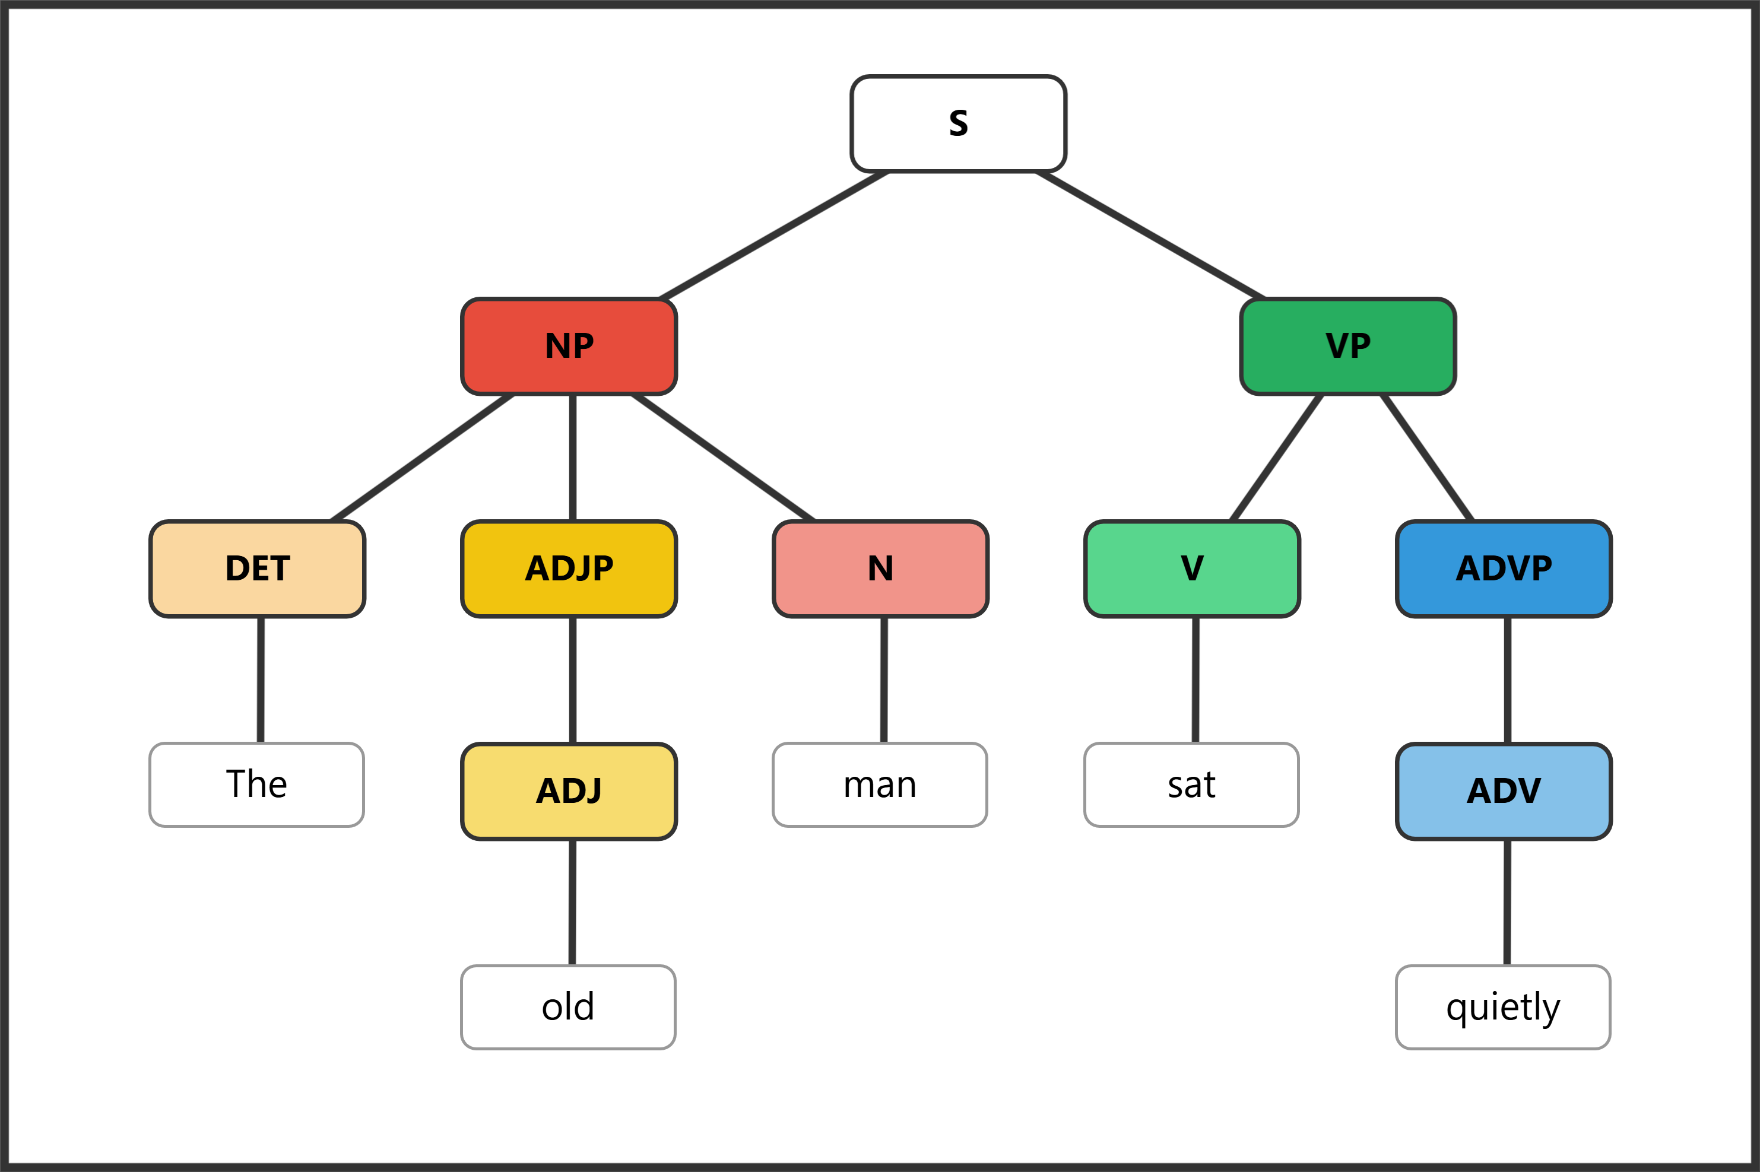

Question 26: (10 pts) The cat slept on her comfy bed.
Role
Phrase
Word | The | cat | slept | on | her | comfy | bed
POS
Diagram: [Create below (by hand) or attach (digital)]

Question 27: (10 pts) The cheerful birds sang beautifully in the garden.
Role
Phrase
Word | The | cheerful | birds | sang | beautifully | in | the | garden
POS
Diagram: [Create below (by hand) or attach (digital)]

Question 28: (10 pts) The students from Ohio studied carefully.
Role
Phrase
Word | The | students | from | Ohio | studied | carefully
POS
Diagram: [Create below (by hand) or attach (digital)]

Question 29: (10 pts) Several brave firefighters worked tirelessly during the dangerous storm.
Role
Phrase
Word | Several | brave | firefighters | worked | tirelessly | during | the | dangerous | storm
POS
Diagram: [Create below (by hand) or attach (digital)]

Question 30: (10 pts) The tall professor with gray hair spoke very eloquently.
Role
Phrase
Word | The | tall | professor | with | gray | hair | spoke | very | eloquently
POS
Diagram: [Create below (by hand) or attach (digital)]

Bonus (10 points)
Instructions: Write original sentences or phrases meeting each requirement below.
Bonus 1: Write a sentence containing a compound word (a word formed from two free morphemes). Underline or circle the compound word and identify its two free morphemes. (2 pts)
___________________________________________________________________________
Free morphemes: ____________________ + ____________________
Bonus 2: Write a sentence containing a prepositional phrase that modifies the verb phrase (not a noun). Underline or circle the prepositional phrase. (2 pts)
___________________________________________________________________________
Bonus 3: Write a word that contains at least three morphemes. List each morpheme and label it as free or bound. (2 pts)
Word: ______________________________
Morphemes: ____________________________________________________________
Bonus 4: Write a noun phrase that contains a determiner, an adjective, and a noun. (2 pts)
___________________________________________________________________________
Bonus 5: Write a sentence in which an adverb modifies an adjective (not a verb). Underline or circle the adverb and identify the adjective it modifies. (2 pts)
Sentence: ____________________________________________________________
Adverb: ____________________ modifies adjective: ____________________

